Social Media Posts for Members
Translate the image in your language and use your IIA logo.
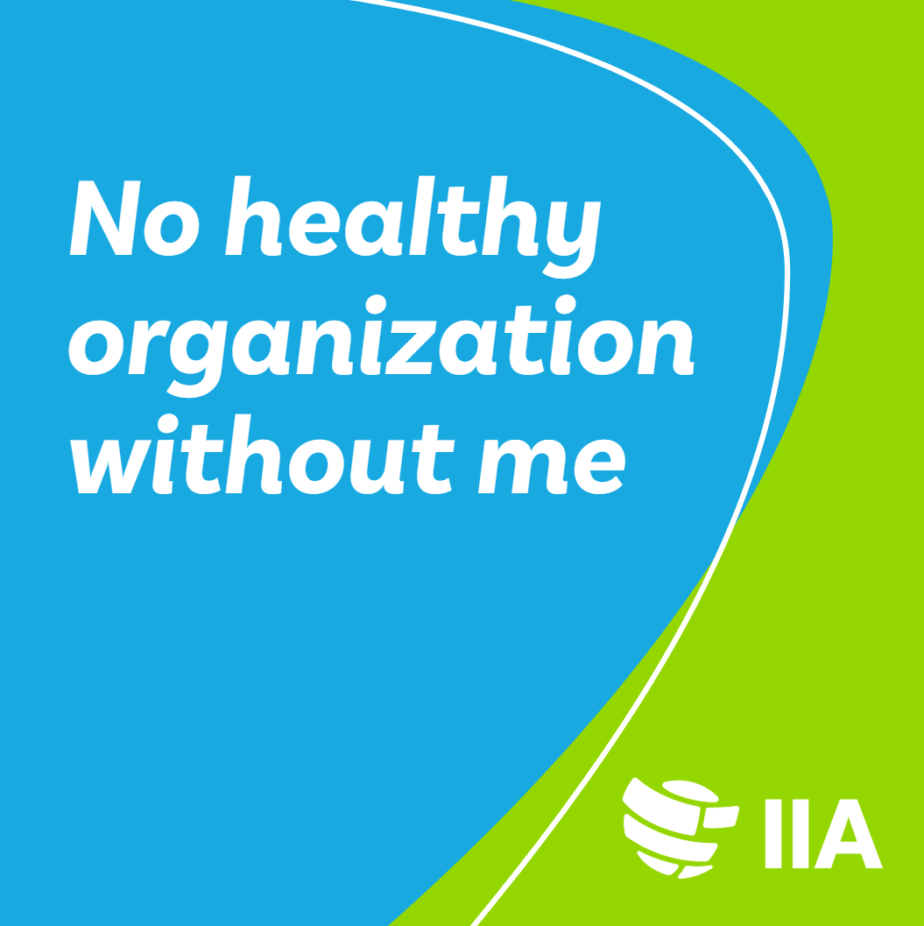 | Empowering Organizations. Enhancing Trust. Elevating Performance. That's the power of Internal Audit.  As an Internal Auditor, I bring a disciplined approach to evaluating and improving governance, risk management, and control processes. My work strengthens organizations from the inside out.  Want to know how Internal Audit drives value across industries? Ask me or learn more at https://www.iiabelgium.org/  #OneIIA #InternalAuditMonth
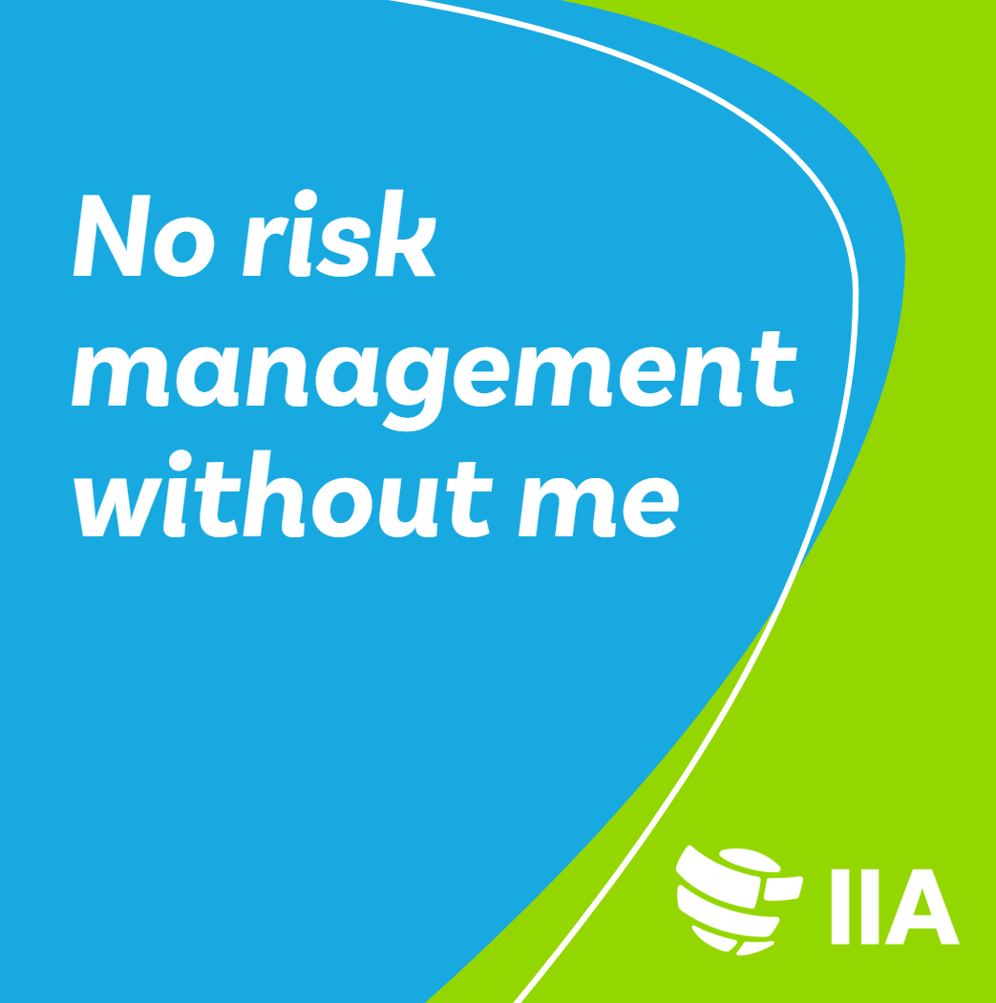 | Navigating Risks. Building Resilience. Inspiring Confidence. That's the power of Internal Audit.  Internal Auditors are the unsung heroes ensuring organizations stay agile, resilient, and future-ready. We offer independent insights that drive strategic improvements.  Ready to discover how Internal Audit supports sustainable growth and effective governance? Ask me or learn more at https://www.iiabelgium.org/  #OneIIA #InternalAuditMonth
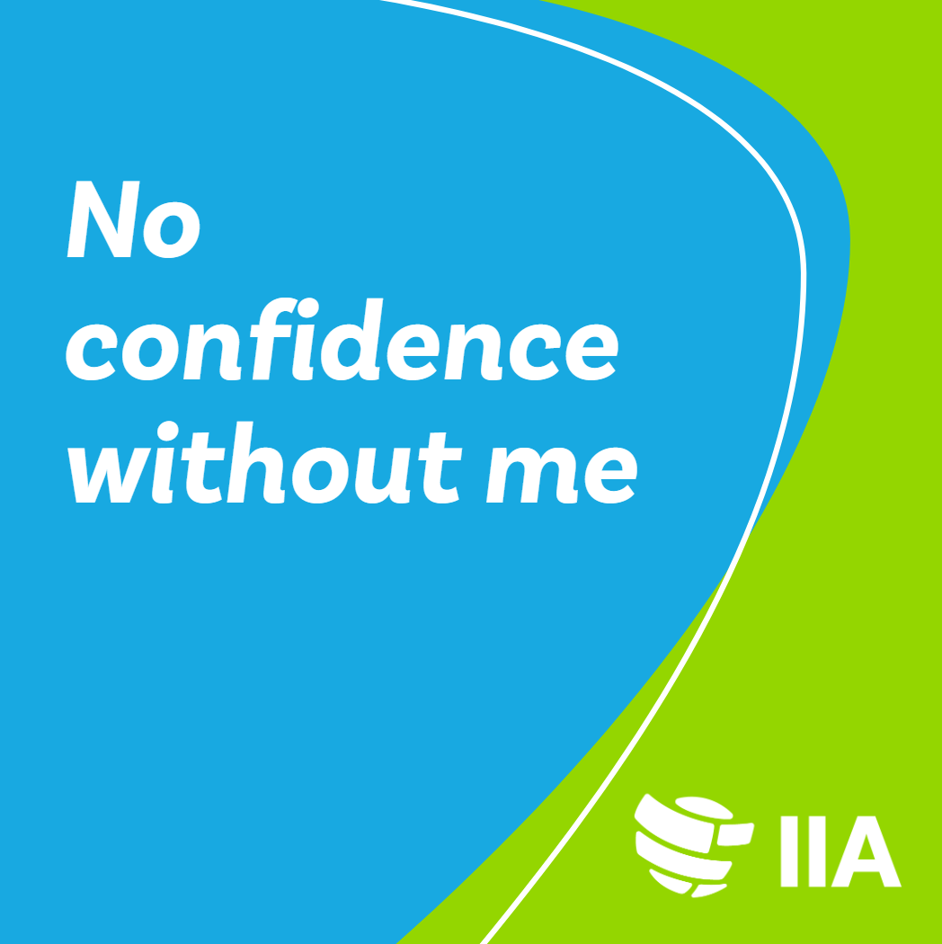 | Assuring Integrity. Enhancing Accountability. Creating Value. That's the power of Internal Audit.  Internal Auditors provide a critical check-and-balance, ensuring organizations meet their objectives with integrity and efficiency. We offer assurance that processes are robust and risks are effectively managed.  Interested in how Internal Audit can sharpen your strategic edge? Ask me or learn more at https://www.iiabelgium.org/  #OneIIA #InternalAuditMonth

